TRIBUWAN UNIVERSITY

INSTITUTE OF ENGINEERING

# KATHMANDU ENGINEERING COLLEGE

KALIMATI, KATHMANDU



LAB-REPORT ON

## Computer Graphics

PRE-DATE:2081-03-17

POST-DATE:2081-03- EXPERIMENT NO:6

SUBMITTED BY: SUBMITTED TO:

NAME: Deepak Thapa DEPARTMENT OF

ROLL:29 COMPUTER ENGINEERING

GROUP: A2

YEAR: III/I

**TITLE: TWO-DIMENSIONAL TRANSFORMATION**

### THEORY

Transformation means changing the graphics by changing the position, orientation or size of the original graphics by applying rules. When transformation occurs in 2D plane, it is called 2D transformations. Basic transformations are:

* Translation
* Scaling
* Rotation

#### Translation

Translation repositions an object along a straight line path from one coordinate location to another. A two dimensional point can be translated by adding translation distances tx and ty to the original co-ordinate position to move the point to a new position (x’,y’). In translation only position is changed but shape and size are unchanged.

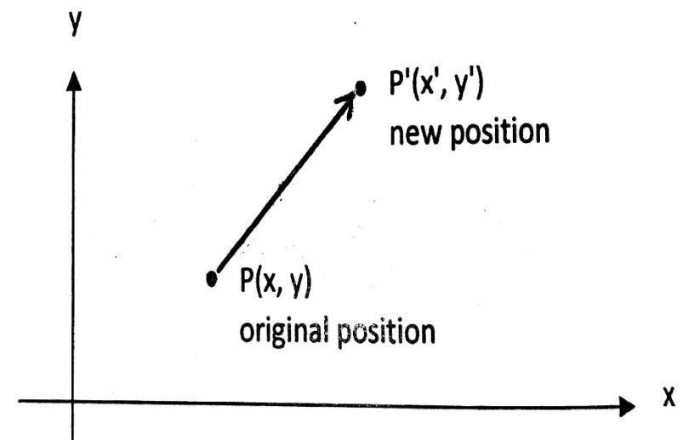

Fig: translation of a point

x’=x+tx y’=y+ty In matrix form,

𝑥′ 𝑥 𝑡𝑥

[𝑦′] = [𝑦] + [𝑡𝑦]

P’=P+T

#### Scaling

Scaling is a basic transformation that alters the size of object. Points can be scaled by sx along x-axis and sy along y-axis. Transformation equations are:

x’=x. sx y’=y. sy In matrix form,

𝑥′ 𝑠𝑥 0 𝑥

[𝑦′] = [0 𝑠𝑦][𝑦]

P’=s.P

If sx=sy it’s called uniform scaling otherwise it’s called differential scaling.

#### Fixed point scaling

The location of the scaled object can be controlled by choosing position calle fixed point that is to remain unchanged after scaling transformation. Fixed point (xf,yf) can be chosen as one of the vertices, centroid of the object or any position.

Steps

1. Translate the object so that fixed point coincides with co-ordinate origin.
2. Scale the object with respect to co-ordinate origin.
3. Use inverse translation to return object to original position.

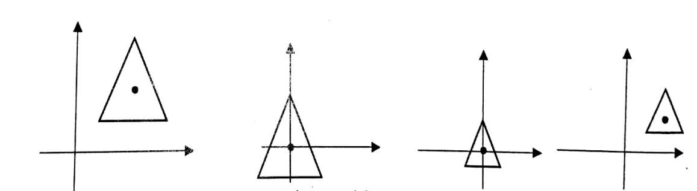

Original translate to origin scaling inverse translation

Fig: fixed point scaling

#### Rotation

Rotation repositions the object along a circular path in the xy plane. To generate rotation, we specify a rotation angle θ and position of the rotation point about which the object is to be rotated. If θ is positive, object is rotated in anticlockwise direction otherwise it’s rotated in clockwise direction.

*Transformation equation for rotation when pivot point is origin*

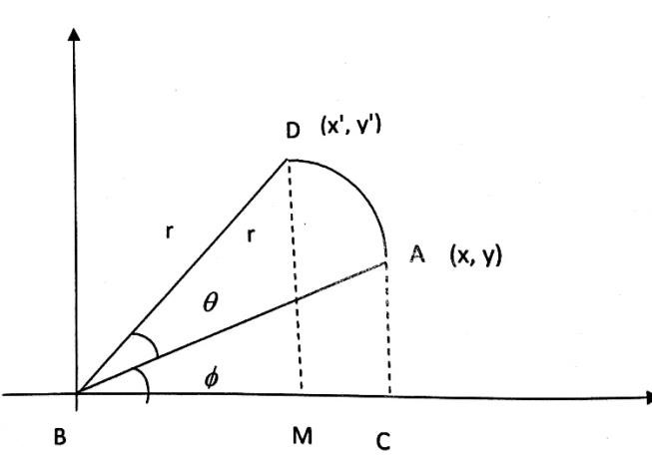

Fig: rotation of a point

From fig,

In ΔABC, x=r cosφ and y=r sinφ In ΔDBM, x’=r cos(θ+φ)

=r cosθ cosφ – r sinθ sinφ

=xcosθ – y sinθ y’= r sin(θ+φ)

=r sinθ cosφ + r cosθ sinφ

=x sinθ + y cosθ

In matrix form,

𝑥′ 𝑐𝑜𝑠𝜃 −𝑠𝑖𝑛𝜃 𝑥

[𝑦′] = [𝑠𝑖𝑛𝜃 𝑐𝑜𝑠𝜃 ][𝑦]

P=R.P

*Rotation of a point about an arbitrary pivot position*

1. Translate object so that pivot point is moved to co-ordinate origin.
2. Rotate object about origin.
3. Translate object so that pivot point is returned to its original position.

### Program code

#include<stdio.h>

#include<conio.h>

#include<graphics.h> #include<math.h> void draw(int a[2][5]); void translate(int a[2][5]); void scale(int a[2][5]); void rotate(int a[2][5]); void main()

{ int a[2][5],i,gd=DETECT,gm; initgraph(&gd,&gm,"C:\\TURBOC3\\BGI"); printf("Enter positions of co-ordinate:"); for(i=0;i<5;i++) { scanf("%d%d",&a[0][i],&a[1][i]);

} draw(a); translate(a); draw(a); scale(a); draw(a); rotate(a); draw(a); getch(); closegraph(); } void draw(int a[2][5])

{ int i=0; for(i=0;i<4;i++) { line(a[0][i],a[1][i],a[0][i+1],a[1][i+1]);

} } void translate(int a[2][5])

{ int i,tx,ty; printf("Enter tx & ty:"); scanf("%d%d",&tx,&ty); for(i=0;i<5;i++) { a[0][i]=a[0][i]+tx; a[1][i]=a[1][i]+ty;

}

} void scale(int a[2][5])

{ int i,sx,sy; printf("Enter sx & sy:"); scanf("%d%d",&sx,&sy); for(i=0;i<5;i++) { a[0][i]=(a[0][i])*sx; a[1][i]=(a[1][i])*sy;

} } void rotate(int a[2][5])

{ int i,temp1,temp2; float angle; printf("Enter angle:"); scanf("%f",&angle); for(i=0;i<5;i++) { temp1=a[0][i]; temp2=a[1][i]; a[0][i]=temp1*cos(angle)-temp2*sin(angle); a[1][i]=temp1*sin(angle)+temp2*cos(angle);

}

}